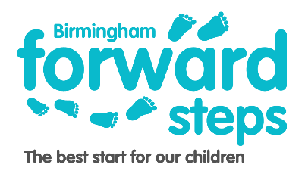

**Now you are 2 group is a 5-week programme for children aged 18-30 months who will be transitioning into nursery.**

Now you are 2 Group

**Ladywood Children Centre**

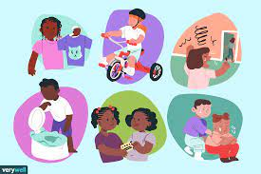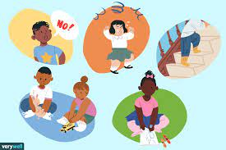

**Key areas that will be covered:**

* **Fine motor and gross motor skills**
* **Independent skills**
* **Routines**
* **Oral health**
* **Book start / language & communication**

**Every Wednesday**

**Starting: Wednesday 19thth January 2022**

**Time: 1:00 – 2:00 pm**

**Location: Ladywood Children’s Centre**

9 Plough & Harrow Road

Ladywood

B16 8UR

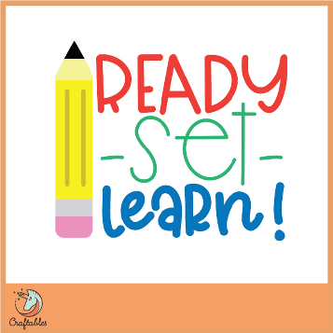

**If you are interested in coming to our session. Please call Ladywood Children Centre on 0121 454 6633 or St. Thomas Children’s Centre on 0121 464 0002 to be added to the waiting list, and we will get back to you.**

**Appointments based only**