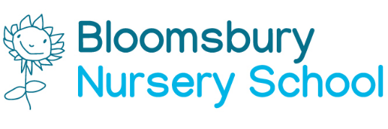

Term Dates 2021/22

Autumn Term 2021 | Spring Term 2022 | Summer Term 2022
Start | Start | Start
Monday 12 September 2021 | Tuesday 04thJanuary 2022 | Monday 25th April 2022
to | to | to
Friday 22nd October 2021 | Friday 18th February 2022 | Friday 27th May 2022
Half Term  Monday 25th October 2021 to Friday 29th October 2021 | Half Term:  Monday 21st February 2022 to Friday 25th February 2022 | Half Term  Monday 30th May to Friday 03rd June 2022
Monday 01st November 2021 | Monday 28th February 2022 | Monday 06th June 2022
to Friday 17th December 2021 | to Friday 8th April 2022 | Wednesday 20th 2022
Christmas Break:  Monday 20th December 2021 to Monday 3rd Jan 2022 | Easter Break:  Monday 11th April to Friday 22nd April 2022 | Summer Break:

Staff Training Days

Thursday 2nd September 2021
Friday 3rd September 2021
Tuesday 4th January 2022
Monday 25th April 2022

In addition, one day during the Summer Term to be arranged when the Nursery will be closed for transition & induction day.

Bank Holidays

New Year’s Day Holiday January 3rd 2021
Good Friday April 15th 2021
Easter Monday April 2021
Early May Bank Holiday May 2nd 2021
Platinum Jubilee Holiday June 3rd 2021
Summer Bank Holiday August 29th 2021

