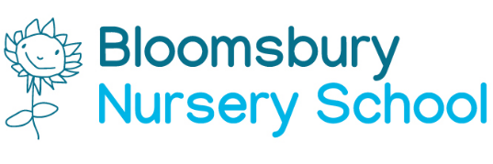

Term Dates 2020/21

Autumn Term 2020 | Spring Term 2021 | Summer Term 2021
Start | Start | Start
Tuesday 1st September 2020 | Monday 04thJanuary 2021 | Monday 19th April 2021
to | to | to
Friday 23rd October 2020 | Friday 12th February 2021 | Friday 28th May 2021
Half Term  Monday 26th October 2020 to Friday 30th October 2020 | Half Term:  Monday 15th February to Friday 19th February 2021 | Half Term  Monday 31st May to Friday 04th June 2021
Monday 02nd November 2020 | Monday 22nd February 2021 | Monday 07th June 2021
to Friday 18th December 2020 | to Thursday 1st April 2021 | to Monday 21st July 2021
Christmas Break:  Monday 21st December 2020 to Friday 1st Jan 2021 | Easter Break:  Monday 6th April to Friday 16th April 2021 | Summer Break:

Staff Training Days

TBC
Children will return to nursery school w/c 7th September.
During w/c 1st September teachers will contact families to arrange settle visits. Home visits will not take place this year due to Covid 19. Families will be invited to attend outdoor Stay & Play sessions with their children.

In addition, one day during the Summer Term to be arranged when the Nursery will be closed for transition & induction day.

Bank Holidays
Friday 1st January – New Year's Day.
Friday 2nd April – Good Friday.
Monday 5th April – Easter Monday.
Monday 3rd May – Early May bank holiday.
Monday 31st May – Spring bank holiday.
Monday 30th August – Summer bank holiday.
Monday 27th December – Christmas Day (substitute day)

